Set 1
Aim
To visualize monthly sales data using a line chart, bar chart, and scatter plot, and to build an interactive dashboard using R and Shiny.
Dataset: Monthly Sales
Month | Sales ($)
January | 15000
February | 18000
March | 22000
April | 20000
May | 23000

PROGRAM 1: Line Chart of Monthly Sales
Create a line chart to visualize the monthly sales. Label the axes and title the chart appropriately.
# Dataset
month <- c("January", "February", "March", "April", "May")
sales <- c(15000, 18000, 22000, 20000, 23000)
# Line Chart
plot(sales,
type = "o",
xaxt = "n",
xlab = "Month",
ylab = "Sales ($)",
main = "Monthly Sales",
col = "blue")
axis(1, at = 1:5, labels = month)
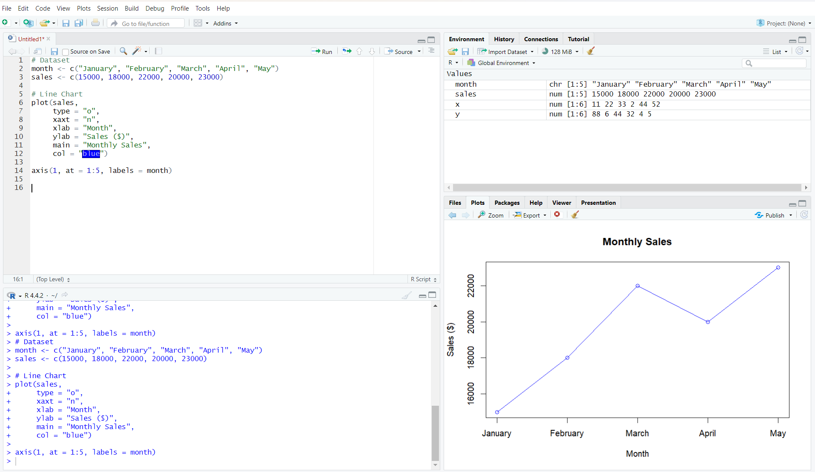
Output 1: Monthly Sales Line Chart
Observation: Sales increase from January to March, decrease slightly in April, and reach the highest value in May.

PROGRAM 2: Bar Chart of Sales
Generate a bar chart to display the sales values for the available months and label the chart elements.
# Dataset
month <- c("January", "February", "March", "April", "May")
sales <- c(15000, 18000, 22000, 20000, 23000)
# Bar Chart
barplot(sales,
names.arg = month,
xlab = "Month",
ylab = "Sales ($)",
main = "Monthly Sales",
col = "skyblue")
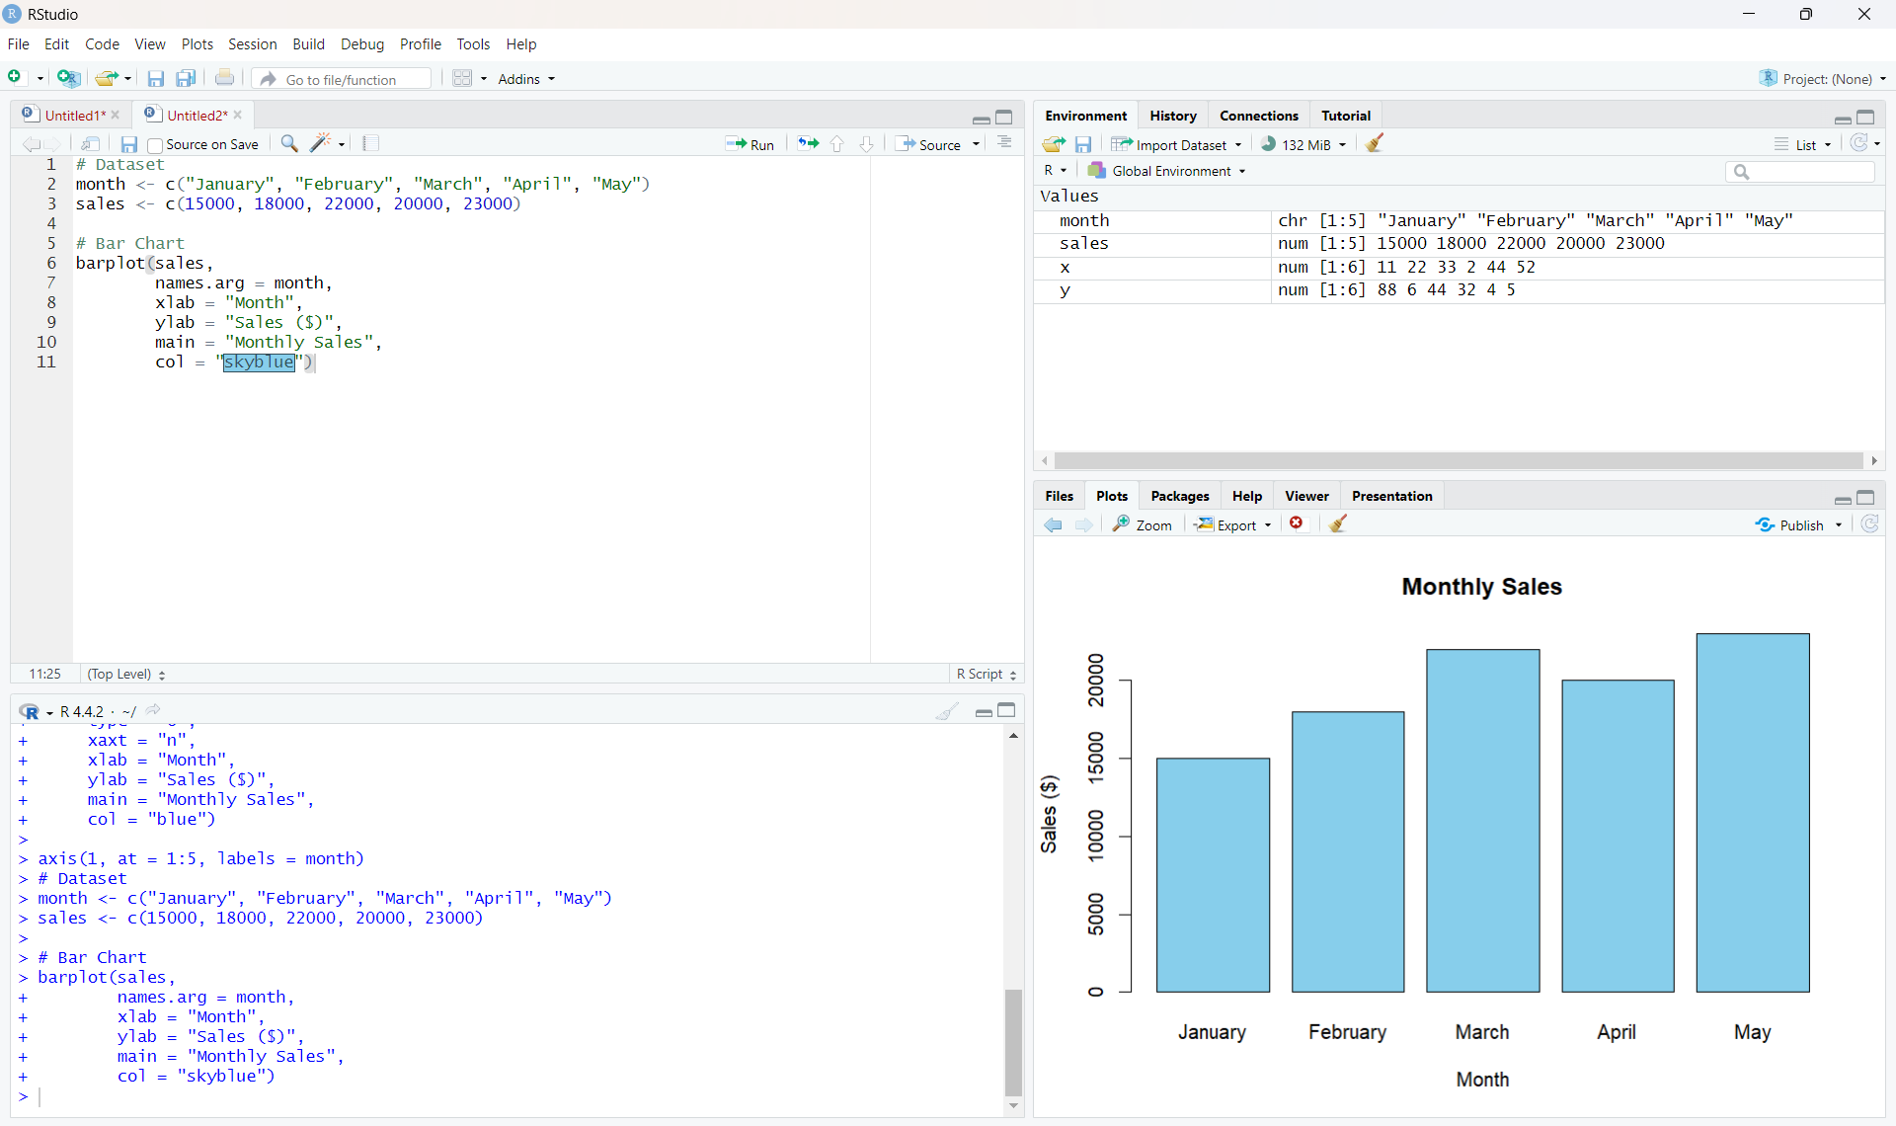
Output 2: Monthly Sales Bar Chart
Observation: The bar chart makes it easy to compare the sales of each month. May has the highest sales and January has the lowest.

PROGRAM 3: Scatter Plot of Advertising Budget vs Monthly Sales
Develop a scatter plot to explore the relationship between advertising budget and monthly sales.
# Dataset
sales <- c(15000, 18000, 22000, 20000, 23000)
advertising <- c(5000, 6000, 7000, 8000, 9000)
# Scatter Plot
plot(advertising, sales,
main = "Advertising Budget vs Monthly Sales",
xlab = "Advertising Budget ($)",
ylab = "Monthly Sales ($)",
pch = 19,
col = "red")
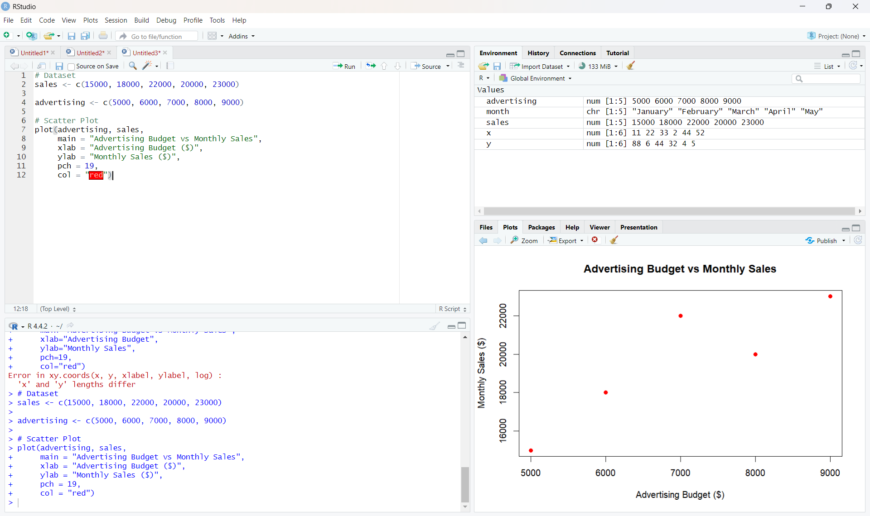
Output 3: Advertising Budget vs Monthly Sales Scatter Plot

PROGRAM 4: Interactive Sales Dashboard
Build an interactive dashboard combining the line chart and bar chart using the Shiny package.
library(shiny)
month <- c("January", "February", "March", "April", "May")
sales <- c(15000, 18000, 22000, 20000, 23000)
ui <- fluidPage(
titlePanel("Monthly Sales Dashboard"),
sidebarLayout(
sidebarPanel(
selectInput("chart",
"Select Chart:",
choices = c("Line Chart", "Bar Chart"))
),
mainPanel(
plotOutput("salesPlot")
)
)
)
server <- function(input, output) {
output$salesPlot <- renderPlot({
if (input$chart == "Line Chart") {
plot(sales,
type = "o",
xaxt = "n",
xlab = "Month",
ylab = "Sales ($)",
main = "Monthly Sales")
axis(1, at = 1:5, labels = month)
} else {
barplot(sales,
names.arg = month,
xlab = "Month",
ylab = "Sales ($)",
main = "Monthly Sales")
}
})
}
shinyApp(ui = ui, server = server)
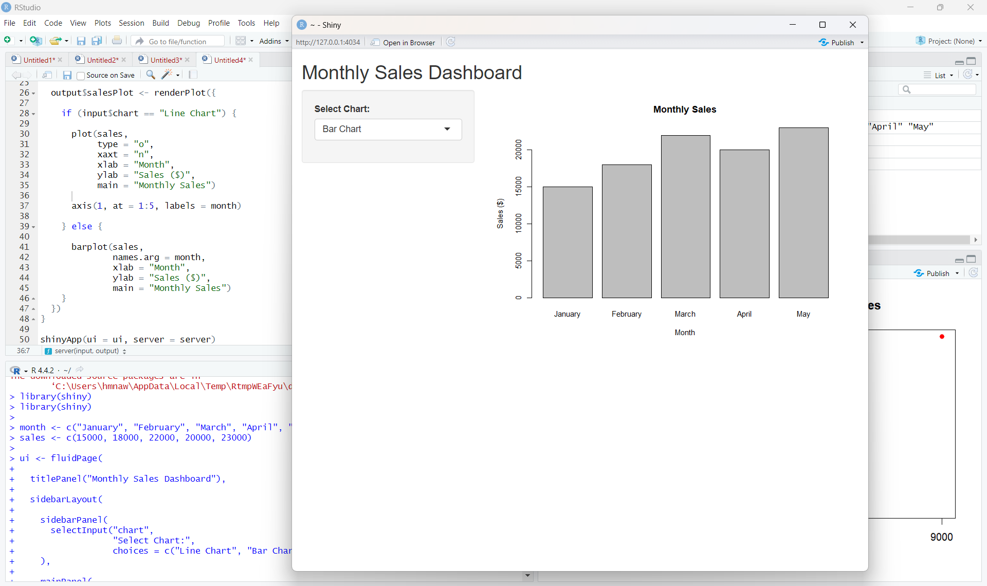
Output 4: Interactive Monthly Sales Dashboard

